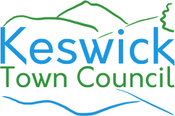
TOWN COUNCILLOR VACANCY

Would you like to help get things done and contribute to the well being of the community in Keswick?
- Keswick Town Council is looking for a new Councillor to join the Town Council. The Council is made up of people from varied ages, backgrounds and genders, who all want to improve the local community.
- It’s a wide-ranging role, from discussing planning applications, organising events for the town, lobbying on local issues such as the Swimming Pool and becoming a Trustee for Fitz and Hope Parks.
- Councillors receive no payment for their time.
Eligibility requirements: To be a Councillor you must be:
- British, Commonwealth or EU citizen
- Aged 18 years or over
- In one of the following categories:
  - Appear on the Electoral Register for the town
  - Have lived in (or within 3 miles of) the town for at least a year
  - Have had your main place of work within the town for at least a year
If you would like more information or to apply please email the Town Clerk at townclerk@keswicktowncouncil.gov.uk or visit our website at www.keswicktowncouncil.gov.uk.

Please return your application to the Town Clerk by Friday 7 August 2026.

